For Raising
Awareness and Consciousness
On Your Ideal Life Journey

My Life-Long Planning Journal
"Personal and Confidential"

Name: ____________________
“New Ways for New Times”
Version: 923A8
Life Planning Binder
and
Transformational Tools for New Times

Contents
INSTRUCTIONS: Life Planning Binder "Quick Start" Setup 2
Personal Daily Dashboard Instructions 5
Dream Calendar Instructions (daily, weekly, monthly, yearly) 6
COFFEE Questions Instructions (daily, weekly, monthly, quarterly) 6
DAILY FORMS 7
Daily Dashboard - #1 (Daily) 7
Dream Calendar on-One-Page 8
WEEKLY FORMS 9
Weekly COFFEE Questions (Weekly) 9
MONTHLY FORMS 10
Starting Inventory/Tracking Form 10
Life Challenges and Healing HOT LIST on One Page 12

INSTRUCTIONS: Life Planning Binder "Quick Start" Setup

Welcome to a flexible life management, life planning, manifesting, awareness, and intuition development system that allows you to customize your experience according to your style, technology, situation, and needs. You will be sent new tools for new times periodically, typically weekly.

We have created a flexible system and process that you can setup in your own Life Planning Binder (recommended), on your computer, and on a 'cloud' for portability and mobile use. So, first there are some decisions to make:
- I want a stand-alone 3-ring binder (recommended) to manage my personal growth, future, intuition develop, and how to manifest my dreams. As you experience your worksheets and cheat sheets, you can customize your system during the training. Obtain a 3 ring plain or zippered binder and a package of 5 '3-ring' dividers.
- I have my own journaling system that I want to use. You can just copy the simple layouts and text of the exercise pages and enter them into your own Journal. You may want to put in a page marker/divider for separate sections in your journal.
- I want an online version on my desktop/laptop/tablet. The files for downloading are Microsoft Word documents you can enter your notes into.
- I would prefer to use my smartphone. You can also store these work pages on a cloud like Google Drive, Evernote, Dropbox, SkyDrive, etc., which is accessible by your smartphone.
Steps
- Download the 10 pages of start up forms, instructions, and cheat sheets.
- Select your system configuration from the above choices and create your system. We recommend a 3-ring binder to start.
- Update your ideal Dream Day (Week, Month, Year) on-one-page Calendar
- Complete your Starting Inventory and Tracking Form and file it under your monthly section.
- Read the reference notes about your Personal Dashboard. Then take 5 to 10 minutes and make your first entries.

If you are using a 3-ring binder, recommended section tabs are:
- (Optional) Calendar for Commitments, Appointments, Plans and Reminders - If you want to incorporate a calendar system, we recommend a week at-a-glance or month at-a-glance calendar depending on how many commitments you have daily.
- Daily Forms - for your Personal Dashboard, daily practices, 'To Do' lists, and other daily tracking and optional growth forms to be added.
- Journal - This is your dumping ground of feelings, ideas, thoughts, doodling, and journaling exercises - whatever you want. Even if it is one word or sentence per day, you will reap rewards.
- Weekly, Monthly, Quarterly Forms - For clearer goal setting, reviews, bigger perspectives, and smart questions periodically use these one-pagers.

- Projects - Here you can create your own projects. Reflect on what’s important to you – dreams, goals, healing, people, projects, writings, lifestyle, retirement, relationships, family, money, work, career, your thoughts, etc. See our list of types of journals for extra ideas. Pick a few topics of interest to you.
- References as a catch all place for your cheat sheets and instructions.

DAILY TASKS

- Come Alive in Five! Start by spending about 5 minutes daily and enter single word or short phrase answers/comments for each section of the Personal Dashboard. Create a routine of making entries a minimum once per day, and ideally once in the morning and once in the evening.
- Review your calendar and TO DO list for commitments and identify your top 3 to 5 things that must be worked on today.

WEEKLY TASKS

- Check your Dream Day (Week, Month) on-one-page Calendar to identify ahead of time new tasks.
- Weekly COFFEE Questions
- More forms to come.

MONTHLY TASKS

- Check your Dream Day (Week, Month, Year) on-one-page Calendar to identify ahead of time new tasks.
- More forms to come for balance, healing, manifesting, Monthly COFFEE Questions and more.

Develop will power through self-discipline. Try it out. Trust the Process. It works. Nothing to lose and a fulfilling life to gain. Leverage your inner work and self nurturing. Open your mind to new possibilities. Answers are all inside of you. Now to draw them out. Intuition is developing. Share your experiences. Learn from others.

To Manifesting More Magic and Miracles

John Robson
john@higherawareness.com

Personal Daily Dashboard Instructions
Daily add at least one word or phrase to each box. These steps create a subtle tension and focus on the inner workings of intuition, wholeness, purpose, new ways of thinking, and the subconscious mind.

The first 6 boxes are more about letting go, surrendering, and raising your consciousness so you become more inclusive and open.

My Pet Peeves, Inner Tensions, and Letting Go - We unravel our subconscious mind by examining what we see in our outer life as it does reflect and is caused by the inner life. This is called projections. As we accept it for what it is and not resist it, judgments and tensions naturally move towards a resolution, a cause, an integration of opposites, and towards a higher quality.

My Motives, Meaning and Learnings - Bring to mind your last 24 hours. Were you even conscious of your motives or did you just do your day robotically? Did you even have an 'intention' or 'question on your mind'? Were you engaged in meaningful activities? If we are not learning, changing, and growing we stay stuck. Each of these are clear indicators you are unifying and elevating your consciousness. A great mantra is "What can I learn from this situation?"

I Want to Be - As you open to answers, elevate who you are. Create an intention of your highest self. BEING is naturally living higher qualities of life. It is a move from judgment and separation towards a more conceptual, purposeful, loving, unifying attitude. On your death bed what would be really important to you? What would be your top regrets? Why not start today?

The last 6 boxes are more about letting in, being responsible and accountable and manifesting by down shifting energy and consciousness into form.

I Want to Do and Have - Deep down our desires and wants are linked to our needs and some aspects of our purpose and who we are. The more we conceptualize and idealize the 'what' and 'why' of what we want to do and have, the more we are embodying it and the more the chances of manifesting it sooner than later.

My Ideas, Urges, Inspirations, Calling, and Questions - Intuition often comes in the form of glimpses, ideas, and questions. It may not make sense right now but as you write them down, a bigger idea starts to unfold. Open to listening for inner voices, synchronicities, coincidences, and inspiration. Intuition is always available, so the more we sensitize ourselves in these exercises the more we will be open to its unexpected guidance.

Emotionalize and embody your goals. Recall your goal(s) and energize them full of passion and emotions.
My Gratitude List - Each day, write 1 to 3 things that you greatly appreciate in your life. Gratitude is very powerful as it insinuates that manifesting has worked and you appreciate the process, laws, and beauty of life.
My Accomplishments - Write down your miracles, synchronicities, insights, and accomplishments. Create an audit trail of successes. Success breeds success. Share your celebrations.

My Action Steps and Intentions - Now from all the insights and higher stimulation of your being, write something NEW you intend to do. You may want to transfer it to your more formal 'To Do' list or calendar.

Dream Calendar Instructions (daily, weekly, monthly, yearly)

Idealize your perfect day, week, month, and year - all on-one-page. Below are some periodic tasks you can add to your dream calendar.

DAILY - waking up, exercise, meditation, journaling, personal dashboard, walks, quality family time, stillness, music, reading, learning, work, commute, inner work power hour, emails, daily review time, bedtime, SELF time, etc.

WEEKLY - shopping, fun, friends, errands, exercise, weekly review, cleaning, meetings, COFFEE questions, errands, update next week plan, family connections, meal planning, house cleaning, etc.

MONTHLY - quality personal time, retreats, payday(s), monthly review, COFFEE questions, review finances, banking, review your goals, car maintenance, etc.

YEARLY - holidays, tax time, events, important birthdays, anniversaries, big goal milestones, house cleaning, yard work, etc.

Check in with your Dream Calendar daily or at least weekly so you can plan your days and weeks from a bigger picture. Since you probably look at your calendar of commitments often each day, add your daily and weekly tasks to your calendar.

COFFEE Questions Instructions (daily, weekly, monthly, quarterly)

If you like using your Personal Dashboard and want to go deeper each day, find 5 to 10 minutes (like during a COFFEE break) and answer either of your day, week, month, quarter, or yearly COFFEE Questions. Look at it as a 'stay in control' microscope for daily smart questions, the naked eye for 'balanced' weekly questions, binoculars for a 'bigger picture' monthly questions, and an intergalactic telescope for quarterly and yearly 'ultimate lifestyle' questions.

Use the COFFEE Questions forms or if you use your own journal, take a page, divide it into 3 by 3 squares and answer your 9 questions briefly in each square. Then next week or month draw a line under last week's/month's entry and add your new entry. You will be amazed at either how stuck you are or how improved you are.

As you ask and answer your questions, observe how your answers come to you. Are you more audio, visual, kinesthetic, or just knowing. If no answers are coming, take a breath and ask the questions emphatically 3 times. Let your subconscious mind know you are serious. Then relax and be open to answers. Do not look at the last answers until you have added your new answers. Keep focusing on how you listen to guidance.

In your dream calendar write down specifically the day and time you will do your COFFEE Questions.

DAILY FORMS

Daily Dashboard - #1 (Daily)
Date | 1. My Pet Peeves | 2. My Inner Tensions | 3. Positive Healing Values
Date | 4. My Daily Motivations | 5. My Learning About Me | 6. I Want to BE …
Date | 7. I Want to DO and HAVE | 8. My Urges, Ideas, Intuits | 9. Emotionalize goals.
Date | 10. I am Grateful For ... | 11. My Results and Miracles | 12. Action Steps/Intentions
Dream Calendar on-One-Page (Daily)
Dream Day | Dream Week - 7 days | Dream Month - 30 days
1:00 a.m. to 5 a.m. | Mon. | 1
 |  | 2
6 |  | 3
 |  | 4
7 | Tues. | 5
 |  | 6
8 |  | 7
 |  | 8
9 | Wed. | 9
 |  | 10
10 |  | 11
 |  | 12
11 | Thurs. | 13
 |  | 14
12 Noon |  | 15
 |  | 16
1 pm. | Fri. | 17
 |  | 18
2 |  | 19
 |  | 20
3 | Sat. | 21
 |  | 22
4 |  | 23
 |  | 24
5 | Sun. | 25
 |  | 26
6 |  | 27
 |  | 28
7 pm to 12 Midnight |  | 29
 |  | 30
Dream Year on One Page - 12 months
Jan. | May | Sep.
Feb. | June | Oct.
Mar. | July | Nov.
April | Aug. | Dec.
WEEKLY FORMS

Weekly COFFEE Questions (Weekly)
Date | 1. My peak experience |  | 2. My biggest challenge | 3. New choices to make
Date | 4. My time wasters  How do I hold myself back? |  | 5. Where am I vulnerable? | 6. How can I experience more stillness?
Date | 7. What areas in my life require more creativity? |  | 8. What relationships need more development? | 9. What goals need more clarity and commitment?
MONTHLY FORMS
Starting Inventory/Tracking Form (Rate each: 1 = low, 10 = high)
Performance Criteria  Date | Start  ______ | Month 1 end  ______ | Month 2 end  ______ | Month 3 end  ______
Confidence and self-esteem

Creativity and imagination

Luck, synchronicities, coincidences, and miracles
Ability to easily manifest goals and dreams

Intuition and self-trust

A good sense of how life and universal laws work
Strong willpower and self-discipline

Self-knowledge of who I am physically

Self-knowledge of who I am emotionally

Self-knowledge of who I am mentally

Self knowledge of who I am spiritually

Clarity as to my life purpose

Having a process, plan or strategy on how to do life
A way to handle and heal crisis, shadows, conflicts and roadblocks
My level of awareness

My commitment level to changing and growing
My ability to anchor new programming into my subconscious mind.
TOTAL | ______ | ______ | ______ | ______
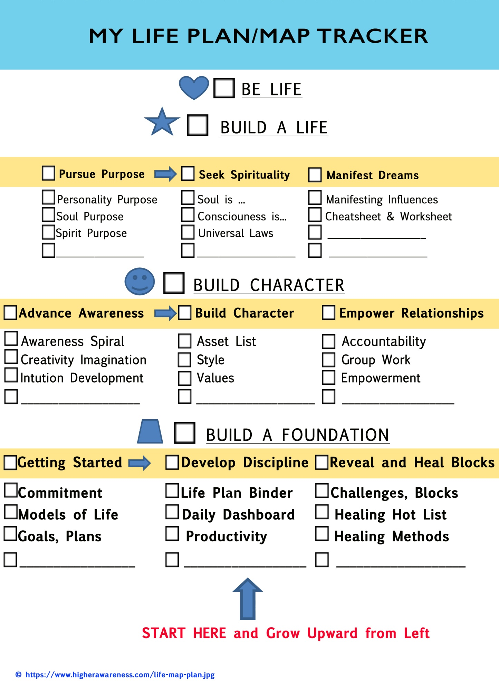

Life Challenges and Healing HOT LIST on One Page (Monthly)
Defence Mechanisms | Excuses and Justifiers | Emotional Reactions
Limiting Beliefs | Victim Positions | Fears
Ego | Stress Sources | Consolidated HOT LIST
Blocks and Life Challenges Instructions
Just follow the instructions and learn how to RESONATE. For each type of challenge (defenses, fears, limiting beliefs, compromises, etc.) we have all of your answers in lists of about 100 choices each. See which challenges resonate with you and circle the top 5 and then from all lists pick your top 10 and add them to your consolidated Healing HOT LIST at the end of the form.

To choose from a larger selection of defenses, scan the list from the link below quickly and mark the defenses mechanisms that you have used. Then pick your top 5 and prioritize them. https://www.higherawareness.com/self-healing/defense-mechanisms.html

Choose from a larger selection of popular excuses and justifiers. Scan the list quickly and mark ones that resonate with you. Then pick your top 5 and prioritize them.
https://www.higherawareness.com/self-healing/excuses-and-justifiers.html

Choose from our large list of emotional reactions.
https://www.higherawareness.com/lists/emotions-and-feelings.html

Our self talk can be very revealing. Choose from our list of common limiting beliefs. Scan the list quickly and mark ones that resonate with you.
https://www.higherawareness.com/self-healing/limiting-beliefs.html

If there is one indicator that you have overcome victim hood and are empowered, it is accountability. Choose from a list of a few hundred energy stealing victim statements. Scan the list below quickly and mark ones that resonate with you.
https://www.higherawareness.com/self-healing/victim-statements.html

Choose from our list of fears. Scan the list below quickly and mark ones that resonate with you.
https://www.higherawareness.com/lists/types-of-fear.html

Choose from our list of ego characteristics. Scan the list below quickly and mark ones that resonate with you.
https://www.higherawareness.com/self-healing/ego.html

Choose from our list of stress sources. Scan the list below quickly and mark ones that resonate with you.
https://www.higherawareness.com/lists/stress-sources.html

Which of the filters below do you use the most?

- defense mechanisms
- excuses and justifiers
- social influences
- limiting beliefs
- victimization
- fears
- ego or
- stress sources.

